Astoria User’s Guide
This document describes Astoria features and its usage in Information Builders, Inc. In addition, instructions are provided to configure XMetaL as the external XML editor for Astoria.
Lily Squires
6/16/2023

Contents
Configuring XMetaL 3
Astoria User Interface 6
Views 6
Presentations 9
Author Steps 12
Book Manager Steps 13
TE / RE Steps 14
Publisher Steps 15
Annotations 16
In XMetaL: 16
In Astoria: 16
Creating XML Documents 17
Tips When Editing XML Documents 17
Setting Table Properties 17
Setting Format attribute for External Web Link 17
Suppressing Page Number in a Cross-Reference 17
Adding mailto in an E-mail Address 18
Working with Bookmaps 21
Editing DN Extension and Release Number: 21
Including Comments in PDF 21
Setting Release Number 22
Editing a Book Map 22
Creating a New Bookmap 23
Using Keywords 25
Defining the KeyWords 25
How to Define a Keyword 26
Adding a Keyword to a Source File 28
Adding a Key Space 28
Using a Set of Keywords for Multiple Manuals/Plugins 30
By Attribute Filtering 31
Snapshot Labels 32
When to Use Snapshot Labels 34
How to Add Snapshot Labels 35
Publishing PDF 37
PDF Publishing Tips 40
Resolving Publishing Messages 40
Resolving Missing Content When Publishing with Snapshot Labels 42
Search Function 43
Find 43
By 44
Operator or @Value 44
@Name is 45
Value 45
Limit 45
Global Substitution 46
How to Use Global Substitution 47
Offline Editing 52
How to Edit an Astoria File Offline: 52
How to Check-in Offline Editing File 54
Resolving Windows Security Message in XMetaL 55

In Astoria, workflow is the vehicle to manage the process of creating/editing technical documentation. Currently there are six roles in a workflow -- Author, Technical Editor, Book Manager, Release Editor, Publisher, and Translation Coordinator.
This workflow begins with the:
- Author chooses either to have a baseline edit conducted for the manual or to begin edits for the next release. The technical document then flows either to the technical editor (TE) or book manager for review.
- Technical editor performs the baseline edits according to our style standards. The document either flows back to the author for review of the TE edits or is set back to initial when no edits are needed.
- Book Manager reviews the file which annotations can be added for author to review. The document then flows back to the author. Once all edited documents are reviewed by the Book Manager, the author sends the document to the PM for review.
- Author evaluates the TE, Book Manager, and PM reviews and makes the necessary edits. There could be several iterations of the review/edit phase.
- Author sends the manual to the Release Editor (RE) for final processing.
- Release editor reviews the edited files according to our standards. The document flows back to the author for review of the RE edits or when no edits are needed.
- Author fills out the DN posting form triggering the Publisher for the manual to be posted.
- Publisher generates several output formats for posting to i-Base and information centers.
- Translation Coordinator exports the files to WorldServer 10 for translation.
It is best to assign more than one TE and RE to a manual to provide adequate coverage in case of absence.
Steps have been outlined for each role in an Astoria workflow.

Configuring XMetaL
After installing XMetaL, configurations unique to IBI are needed:
- Copy ct_config.xml (L:\DS1\Manuals\OSS\SOFTWARE\XMETAL) to replace it in
C:\Program Files (x86)\XMetaL 10.0\Author\Conditional Text\configs.
This is the list of conditions that we use to apply conditional text. Note: You may need to copy from our server to your desktop to replace this file.
Next, we need to turn off word wrapping in XMetaL. This is to prevent title from appearing on mutlitple lines when publishing.
- Open XMetaL as administrator by right-clicking XMetaL shortcut and select Run as administrator.
- Under the Tools menu, click Macros.
- From the bottom, select the second item, DITA Configuration: Turn OFF Pretty-Printing, and click Run.
- Click OK for each of the dialog boxes.
- Back to the Tools menu and select Options.
- Refer to the image to configure the General and View options.
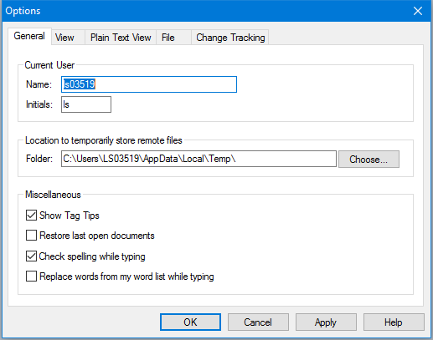
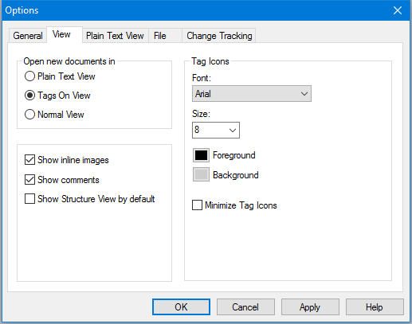
- Click Apply and then OK to save changes.
- Again to the Tools menu, select DITA Options > Update Content tab.
- Select the appropriate check boxes indicated in this image:
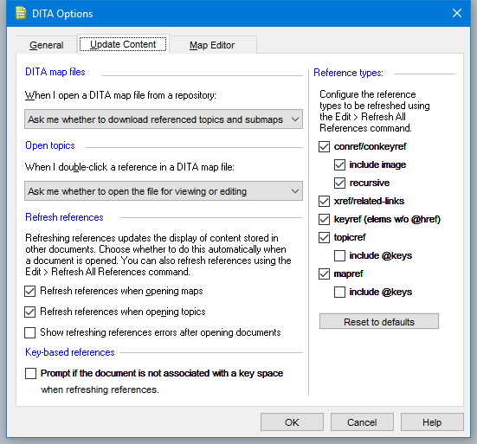
- Click OK.
- You are done. Close XMetaL.
Now you can launch Astoria Workbench from this URL: http://ibiappsa.ibi.com/ier/login
- Under Get Started (the right side), click Launch Workbench and sign in with your global ID and password.
- Upper right corner, click the Preferences icon, 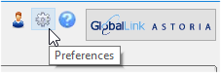.
- Change the settings as indicated in the image:
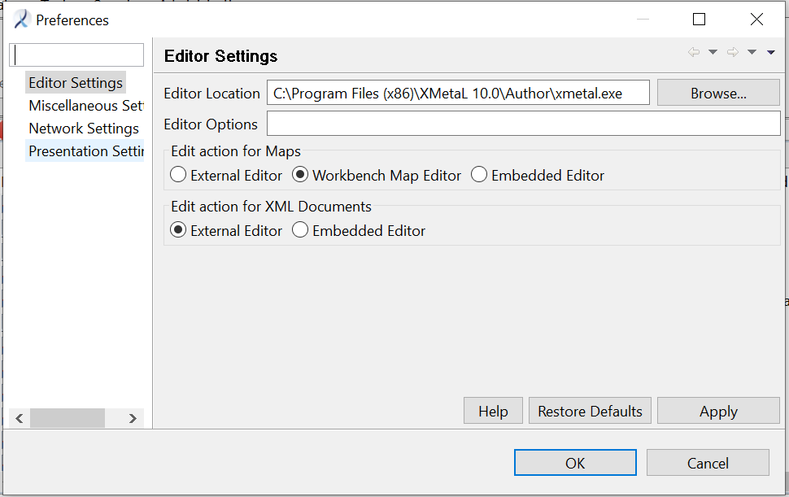
- Click Apply and then OK.
- Go to the Administration menu and click Install WAN Bridge.
- Click the link in step 1 and follow the wizard to install the bridge between Astoria to XMetaL.
- When done, close Astoria (click the X icon upper right corner).
Sign back in to Astoria (create a shortcut on your desktop for quick access) and begin your edits.

Astoria User Interface
Astoria is a configurable user interface that can be personalized according to your documentation responsibility. There are two sections that are covered in this guide: Views and Presentations

Views
There are six panes or views as Astoria calls them.
Navigation View:
The Navigation view provides access to all items that you are authorized to view. You can open files and structured documents for editing or select objects for operations, such as importing or exporting.
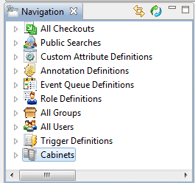
Properties View:
This view displays information about the selected object.
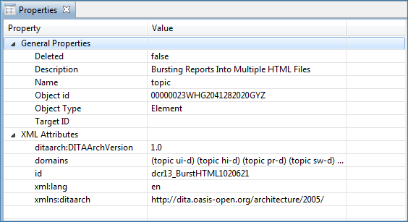

Recent Activity View:
This view displays a list of recently accessed objects. When you invoke a command on an object or try to view the object in the workbench, the object gets added in the recent activity view.
The recent activity view includes columns, such as Name and Description. The objects in this view include context menus, hence operations can be invoked directly on these items.
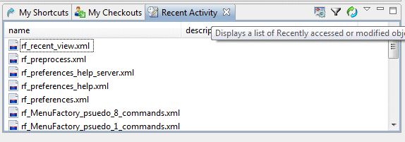
My Shortcuts View:
This view displays objects or folders that you frequently refer to. This view allows you to access an object or folder without navigating through the usual paths. This is useful if you need to modify or refer to an object repeatedly over several sessions. You can add and remove references to objects in the view as needed.
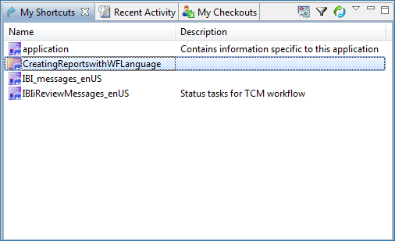

My Checkouts View:
This view displays a list of files that you have been checked out.
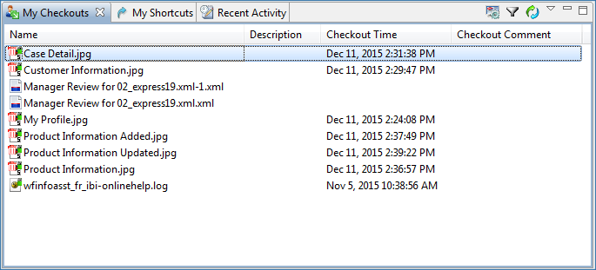
Browse View:
This view displays the contents of the file you selected. You invoke this view by right-clicking the file and select File > View.
Note: When the browse view is active, keyboard and mouse actions are delivered to the browser. For example, on the Windows platform, CTRL and + or CTRL and mouse wheel up will zoom in and CTRL and - or CTRL and mouse wheel down will zoom out.
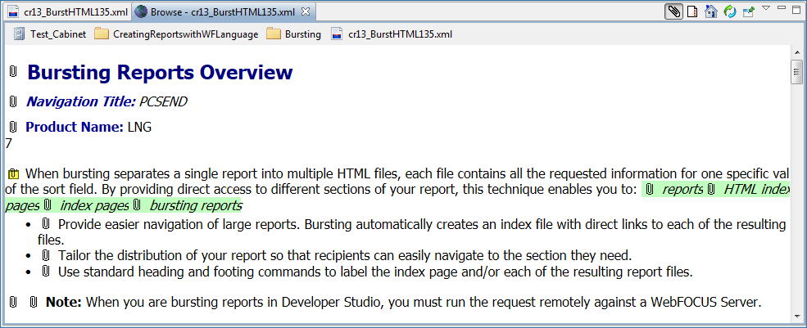
Details View:
The Details View lists the contents contained in the object selected by you.
In this view, you can perform operations such as copying, moving, creating new objects, comparing objects with each other, and performing team operations.
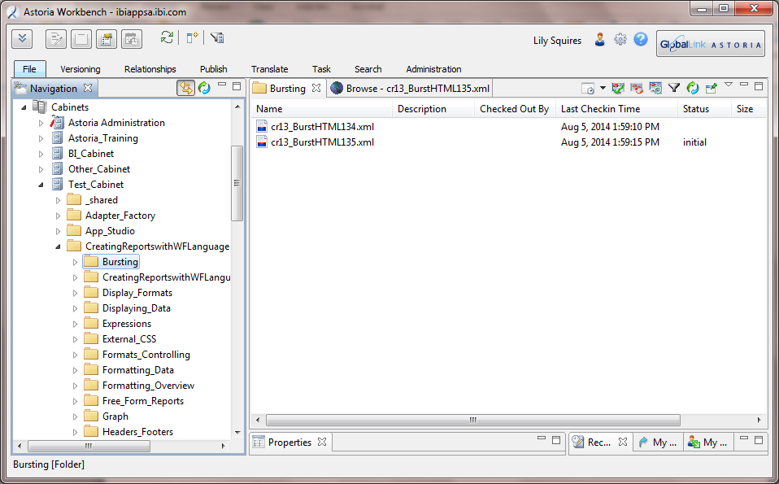

Presentations
You can configure how particular objects are displayed in tabular views. You can add, edit, and delete a presentation.
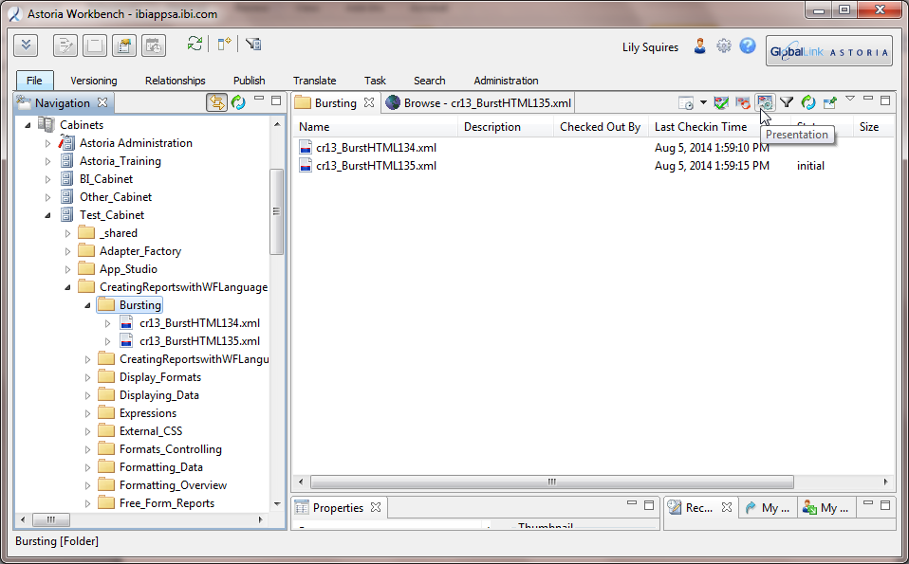
To Configure a Presentation:
- Select the view that you wish to configure the presentation and click the Presentation icon.
- Click the Add Column.
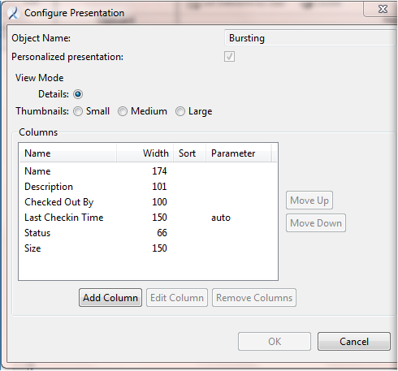

- Select the column to add to your presentation and click OK.
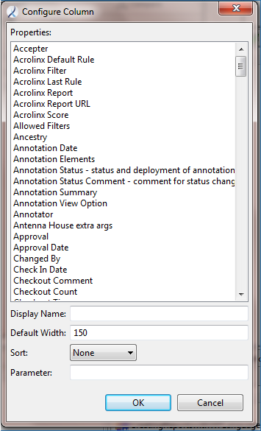
- Move the added column to the position you desired by clicking the Move Up button. Click OK to save the changes.

Author Steps
- Select a file in the Navigation pane and select the Task tab, click Change Status.
- From the Change Status dialog box, select either:
TE Review
  - (Optional) Select a due date to complete the review.
  - (Optional) In the Job Note field, enter any specifics you wish to relay to the Tech Editor.
Note: This will be displayed in the email when sent to the assigned Tech Editor.
  - Click OK.
Initial Release Revision
- No additional selections is needed, click OK.
If there is no need for baseline technical review, choose Initial Release Revision.
Editing a File:
- Right-click a file and select Edit. XMetaL opens.
- Select Track Changes before beginning your edits.
- When you complete the revision, select Check In Document from the Repository menu.
- Click Yes to save changes.
- Add a description in the Version Note box.
Note: It is strongly recommended to add a description to the changes made in file. This assists in deciding which previous versions to roll forward should there be a need.
- In New Status field, select either Manager Review or RE Review.
If there is no need for book manager review, choose RE Review.
- (Optional) Select a due date to complete the review.
- In the Job Note field, enter any specifics you wish to relay which will be displayed in the email.
- Click OK. Close XMetaL. An email is sent to the assigned reviewer for the manual.
Reviewing a File:
- When email is sent to you that the reviewer made edits, click the Task menu and then Jobs Assigned to <Author Name>. Select the file listed in the email and click Accept Job.
- In the Navigation Pane, right-click the file and select Edit. XMetaL opens.
- Accept or reject the edits. When done, check in the file, add version and job notes, designate due date.
- In the New Status field, select either Reject Mgr Edits or RE Review.
Note: Choose Reject Mgr Edits when an online discussion is warranted about edits made by the Book Manager.
There may be several rounds of Book Manager edit/review phase.

- When RE review is done, set the file’s status to one of the following:
  - Publish for Posting when the final file for the manual has completed RE.
Remember: The DN posting form still needs to be completed for publishing.
  - Send WS Translation when translation is needed.
  - initial when there are other files to be edited before the manual is ready for publishing.
Adding a Release Number to a Revised Manual:
Once the manual has been approved for the latest release, Astoria can store its updates by using a Snapshot Label and a time stamp.
- Set the release version at the bookmap level, example: i_rg.ditamap:
Note: By setting the Snapshot Label at the bookmap level, all files listed in the bookmap will inherit the label. More information on Snapshot Labels are in topic, Setting Release Number.
  - Select the Versioning tab to click Add Snapshot.
  - Click the drop-down list in the Snapshot Label field to select the release number. Click OK.

Book Manager Steps
In XMetaL:
- Click the Task menu and then Jobs Assigned to <Book Manager Name>. Select the file listed in the email and click Accept Job.
- Right-click a file and select Edit. XMetaL opens.
- Select Track Changes before beginning your edits.
- When you complete the revision, select Check-in Document from the Repository menu.
- Click Yes to save changes.
- Add a description in the Version Note box.
Note: This assists in deciding which previous versions to roll forward should there be a need.
- In New Status field, select either Review Mgr Edits or No Mgr Review Edits.
- (Optional) In the Job Note field, enter any specifics you wish to relay which will be displayed in the email.
- Click OK. Close XMetaL. An email is sent to the author.
If you are only commenting rather than editing while reviewing the file, use the annotation feature. See Annotations for instructions.

TE / RE Steps
- Click the Task tab and select Jobs Assigned to <TE Name>. Select the file listed in the email and click Accept Job.
- Select the File tab and click Edit. XMetaL opens.
- Go to Tools and click Track Changes.
- Make the edits.
- From the Repository menu, click Check In Document.
- Click Yes to save changes.
- Add a description in the Version Note box.
Note: This assists in deciding which previous version to roll forward.
- (Optional) In the Job Note field, enter any specifics you wish to relay to the Author.
Note: This will be displayed in the email sent to the Author.
- In New Status field, select:
  - Review TE Edits -- TE review is done and there are edits for writer to review,
  - Initial -- TE review is done and no edits for writer to review,
  - Review RE Edits -- RE review is done and there are edits for writer to review, or
  - No RE Edits -- RE review is done and no edits for writer to review.
- Click OK. An email is sent to the author to review the edits.
- Close XMetaL.

Publisher Steps
- In the Navigation pane, select the ditamap and go to the Publish tab. Click Compose With DITA-OT.
- Double-click ibi-pdf to add to the Present pane. More than one output can be generated.
When publishing is completed, an email will be sent with a zip attachment.
- Open the zip attachment to view the batch_err_xxxx.txt error log file.
xxxx is the unique id that Astoria assigns.
- Resolve the errors, if any and re-publish, and review the error log file. See Resolving Publishing Messages.
- Navigate to \\ibiappsa\Output\ibi-pdf\en-us\ open the PDF.
Note: This is the folder where all published PDFs will be located.
- Save the PDF to either your desktop or network.
Caution: Repeated publishing of the same PDF will be overwritten.
- In the Navigation pane, select the last file and go to the Task tab to click Change Status.
- Set the file’s status to initial. Click OK.

Annotations

In XMetaL:
- To view annotations:
  - Move the cursor to the beginning of the title element tag.
Note: This prevents from getting an error message in viewing annotations since the concept/topic element tag does not allow annotation to be added.
  - Select Repository > Astoria > Show Annotations.
  - Click the Next button to see the first of the annotation series.
  - Make the edits associated with the annotation and any other edits during a review.
  - Change the Annotation Status to one of the listed values; optionally, add a comment to the changed annotation status.
Note: Do not close the Annotation dialog box. You can make the edits while it is open.
  - Click the Next button for more annotations until all annotations have been reviewed. Click OK.
- To add annotations:
  - Select the element tag where the note is to be added and select from the menu Repository > Astoria > Show Annotations.
  - Click the Add button and select Content Review. Click OK.
  - In the Comment box, add your annotation. Leave the Annotation Status as waiting for decision. Optionally, add a comment to the changed annotation status.
  - Click OK.

In Astoria:
- To add annotations:
  - Right-click a file and select View.
  - Click the desired paperclip to open the Annotation dialog box.
  - Click the Add button, select Content Review and click OK.
  - Type in the Comment box.
  - Leave "waiting for decision" in the Annotation status field.
  - (Optional) Add a comment to the Annotation Status Comment field.
  - Click OK. The paperclip turns into a sticking note .
- To view annotations:
  - Right-click a file and select View.
  - Click any paperclip to open the Annotation dialog box.
  - Select the Next button to see the first annotation.
  - Continue clicking the Next button until the message, "There are no more annotations".
  - Click OK to close the Annotation dialog box.

Creating XML Documents
Astoria provides several XML templates that serve as the basis for creating XML documents.
We had customized these templates according to our IBI standards. This set of customized XML document templates are located in BI_Cabinet > _Document_Templates.
- IBI_Topic.xml: Select this template to create a Heading 1 topic.
Note: For a topic box to be displayed, add mytoc to the otherprops attribute at the topic tag.
- IBI_Concept.xml: Select this template to create Heading 2 to Heading 4 topics
- IBI_Task.xml: Select this template to create a Procedure topic.
- IBI_Reference.xml: Select this template to create a Reference or Syntax topic.
Assign ref or syn for reference or syntax, respectively, to the otherprops attribute at the reference tag.
- Bookmap.ditamap: Select this template to create a book with chapter topics. Most commonly used for publishing PDFs.
- map.ditamap: Select this template to create Help or a Tech Library. This is for publishing HTML files that are part of a Help system or Technical Library.
To create a new XML document:
- Right-click a folder and select New XML Document.
- At the Name field, type a file name.
- Click either the Browse or Defaults button.
- Navigate to the BI_Cabinent > _Document_Templates folder.
- Select an IBI template. Click OK.

Tips When Editing XML Documents

Setting Table Properties
For our documentation, the standard settings for tables are:
- Headers: The table headers will carry on to following pages
- Picas: The table measurement type
- Border: At tgroup attributes – colsep=1 and rowsep=1

Setting Format attribute for External Web Link
- Web link with https and with mixed case, the format attribute set as "http"
- Web link with http and with mixed case, leave format attribute empty
- Web link with https and with all lowercase, the format attribute set as "https"
- Web link with http, the format attribute set as "http"

Suppressing Page Number in a Cross-Reference
In the type attribute of an xref tag, enter section to suppress the page number.

Adding mailto in an E-mail Address
- From the XMetaL’s Insert menu, select Link > Web Link.
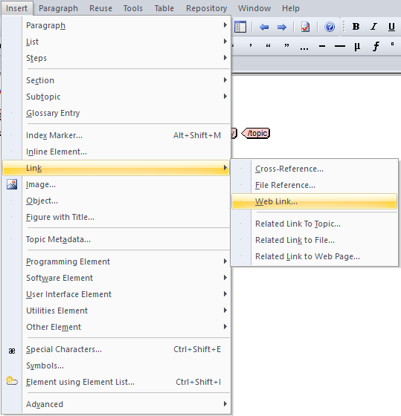
- Type mailto: email address. Click OK.
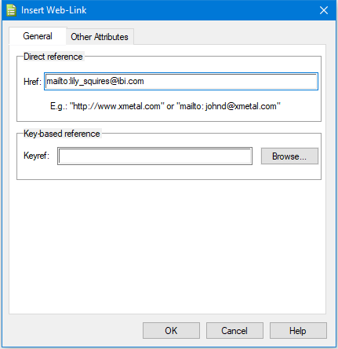
- Replace the highlighted text in the xref tag with text you wish to appear.
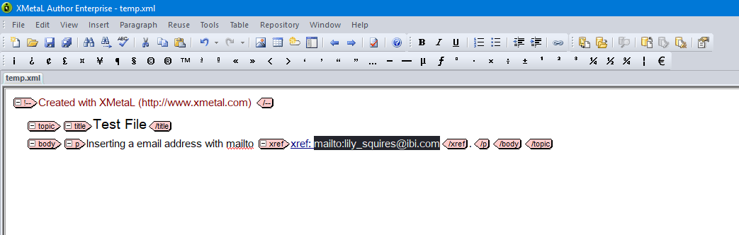
- Notice in the Attribute Inspector list that certain attributes are automatically filled in for the email address to work.
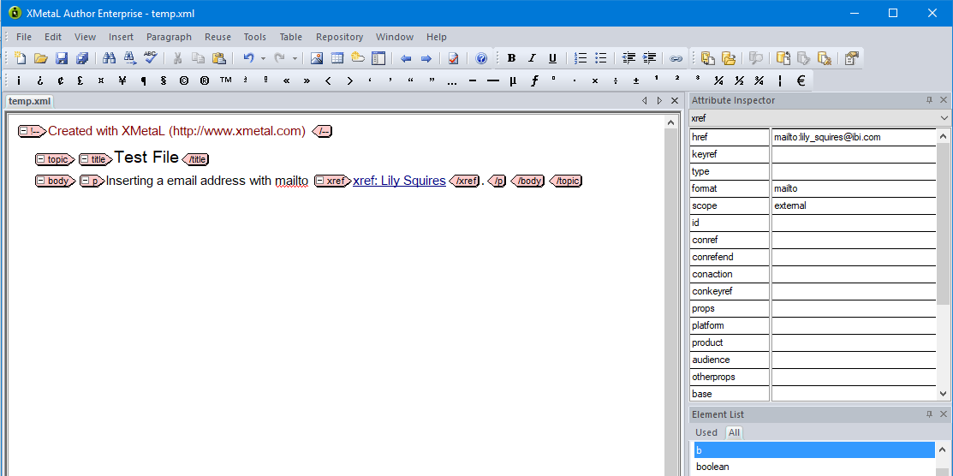

Working with Bookmaps

Editing DN Extension and Release Number:
- In the Navigation pane, right-click the ditamap file and select Edit.
Content of the ditamap file opens in the Document Structure pane.
- Expand bookmeta > bookid > booknumber; click the DN.
The Element Details opens below the Document Structure pane.
- Click inside the Element Details pane to update the DN extension.
- Close the ditamap by clicking the X icon.
The Close Map Editor displays.
- Click the Save/Checkin button to save the changes.
You would use this same method to edit the release number that is located under booktitle > booktitlealt.

Including Comments in PDF
- Edit the ditamap.
- Right-click the bookmeta element and select Add Child and then author.
- Right-click the author element and select #PCDATA.
- Type comments.
- Click x in the tab and select Save & Checkin.

Setting Release Number
In Astoria, this is referred to as Snapshot Label. Snapshot Label can be set at:
- Map level
- File level
- Element level
Snapshot Label is set when the manual has been finalized and approved by the product manager. This is set at the map level which all listed files in the map will inherit the Snapshot Label. This will "capture" all the updates for the specified release and publishing for this release can be selected at any time.
Should an edit is needed for an earlier release, set the Snapshot Label at the file level where the edit appears.
- From the Navigation pane, select the map or file to set the Snapshot Label.
- Go to the Versioning tab, click Add Snapshot.
- Click the drop-down list in the Snapshot Label field to select the release number. Click OK.

Editing a Book Map
The DITA Map Editor is a tool for editing DITA Maps in Astoria. Using the DITA Map Editor requires little or no XML expertise. As it works within the Workbench, no separate editor is needed. This saves you time and simplifies your task.
The Workbench presents the hierarchical DITA Map structure as a tree, similar to a table of contents, and allows easy organization and reorganization of the tree. In addition, the DITA Map Editor allows you to drag and drop topics in the map.
- Right-click the bookmap and select Edit.
- In the Navigation view, open the folder where topics are to be added to the map.
Add new chapter:
- Right-click and select either Add Before or Add After and then chapter.
- Click Add Attribute > href.
- Browse to the chapter topic and select the file. Click OK.
- Click Add Attribute > navtitle.
- Type the title and click OK.
Add a new topic:
- From the Navigation view, drag and drop to the location on the map.
Dragging and dropping an object depends on the location where the action results in the following:
- If you drop an item on another item, it becomes a child of that item.
- If you drop an item above or below another item, it becomes a sibling of that item.

Save the bookmap:
- When done editing the bookmap, click the X icon in the ditamap tab.
- Click Save & Checkin.
- Type a description of the edits made in the Version Note field. Click OK.

Creating a New Bookmap
When creating or editing a bookmap, two panes are displayed:
- Document Structure (top pane) – Display the element tags hierarchical level of the bookmap. The hierarchical selection available to construct the bookmap are:
  - Add Before
  - Add After
  - Add Child
- Element Details (bottom pane) – Add or Edit the attributes of the element tag.
Adding a new bookmap in a folder:
- Right-click a folder and select New XML Document.
- At the Name field, type a bookmap name.
- Click the Defaults button.
- Navigate to the BI_Cabinent > _Document_Templates folder.
- Select Bookmap.ditamap. Click OK.
- Right-click the new bookmap and select Edit.
- Click bookmap to show attributes in the Element Details pane.
- Select id and click Edit Attribute.
- Type a logical short name, e.g. BI_Portal, to easily locate the folder of a published output.
- Back to the Document Structure pane above, expand booktitle to mainbooktitle.
- Right-click mainbooktitle and select Add Child > #PCDATA.
- In the Element Details pane, type a title for the ditamap.
Adding the Release Number:
- Right-click booktitle and select Add Child > booktitlealt.
- Right-click booktitlealt and select Add Child > #PCDATA.
- In the Element Details pane, type the release number.
Adding the book metadata:
- Right-click booktitle and select Add After > bookmeta.
- Right-click bookmeta and select Add Child > category.
- Right-click category and select Add Child > #PCDATA.
- In the Element Details pane, type a product name. For example, WebFOCUS InfoAssist+.
- Right-click bookmeta and select Add Child > bookid.
- Right-click bookid and select Add Child > booknumber.
- Right-click booknumber and select Add Child > #PCDATA.
- In the Element Details pane, type the DN number.
Adding a preface:
- In the Document Structure pane, right-click frontmatter and select Add Child > preface.
  - Click Add Attribute in the Element Details pane and select href.
  - Click the Browse Topic button to locate the file and click OK twice.
If there is no preface, you can skip this step.
Adding a chapter and its topics:
- Select chapter and click Add Attribute in the Element Details pane.
  - Select href and click the Browse Topic button to locate the file for the chapter heading.
  - Click OK twice.
- For the chapter’s H2s, you can drag-and-drop the files into this chapter.
Caution:
The drag-and-drop method takes some practice to properly align the chapter’s subtopics. If a circle with a slash appears, it means it is not a valid position. All H2’s should be indented under the chapter level.
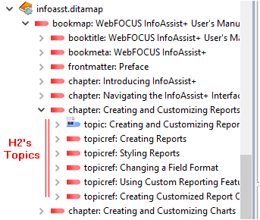
- To add additional chapters, right-click an existing chapter and select Add After > chapter.
- Follow steps 13 – 14.
Adding the index:
- Right-click the last chapter and select Add After > backmatter.
- Right-click backmatter and select Add Child > booklists.
- Right-click booklists and select Add Child > indexlist.
Saving the bookmap:
- When done editing the bookmap, click the X icon in the ditamap tab.
- Click Save & Checkin.
- Type a description of the edits made in the Version Note field. Click OK.

Using Keywords
Since Astoria supports DITA 1.2, we can use now keywords as variables. This will make sharing content much easier and eliminate much of the conditional material we currently maintain.
They require separate ditamaps for manuals/plugins that use different variable values.

Defining the KeyWords
There are two ways to define the keywords:
- In the individual bookmap or map file for each manual or plugin.
or
- In one map file that can be used in multiple ditamaps.
In either case, the keyword is defined the same way, as follows:
<keydef keys="VARIABLE_NAME">
<topicmeta>
<keywords>
<keyword>VARIABLE VALUE</keyword>
</keywords>
</topicmeta>
</keydef>
where:
VARIABLE_NAME
Is the variable name which will be used in the keyword element’s keyref attribute. For consistency sake, the recommended variable names are:
App_Name – to identify the application, WebFOCUS, FOCUS, Db2 Web Query
Prod_Name1 – to identify the product, App Studio or Developer Workbench
Prod_Name2 – to identify another product that are used within the same doc, ReportCaster or Report Broker
VARIABLE VALUE
Is the word or phrase that this variable will represent in a particular manual or plugin. The variable values are listed above.

How to Define a Keyword
- In a map file, add a keydef as a child of the map or a child in the backmatter of a bookmap:
- Add a keys attribute to the keydef.
- Enter the name for the keys in the Edit Attribute dialog box, in this case Product_Name and click OK.

- Add a topicmeta element as a child of the keydef.
- Add a keywords element as a child of the topicmeta element.
- Add a keyword element as a child of the keywords element.
- Add a #PCDATA element as a child of the keyword element.
- Enter the value for the variable in the Element Details text field.
The keydef will look like this:
The same procedure will work in a bookmap, except the keydef will have to be a child of the frontmatter (or backmatter) element.

Adding a Keyword to a Source File
- Edit the source file in XMetal.
- Delete the conditionalized phrase.
- Insert a keyword instead.
- Delete the text inside the keyword element (Keyword).
- Type the keys name in the keyref attribute.
The keyword will be replaced on output with the value of the keyword in the ditamap file.
Warning: If the keyword element includes text (XMetaL puts in “Keyword” by default), that text will appear instead of the value in the ditamap. It may be possible to adjust the customizations to override this behavior.

Adding a Key Space
Instead of entering the keyref attribute in the keyword element by hand, adding a key space will make it more automatic.
- Click the ellipsis (…) next to the attribute.
The Select Key dialog box opens.
- Click Add.
The Add Key Space dialog box opens.
- Click Browse.
The Select from DITAMAP Document dialog box opens.
- Navigate to the ditamap with the keydef and click OK.
The keyword is added to the Select Key dialog box, as shown in the following image.
- Select the Key and click OK.
The keyref attribute is populated.
Warning: The value of the key from the ditamap is inserted in the keyword element. It must be removed or it will be used instead of values from alternate maps.

Using a Set of Keywords for Multiple Manuals/Plugins
If you have a set of keywords that need to be used in multiple manuals/plugins, you can create a map file with the keywords and mapref it into multiple ditamaps.
- Create a map file.
- Add the keydefs as explained in How to Define a Keyword.
- Include the map file in other ditamaps as a mapref.
- In a bookmap, it can be a child of the frontmatter.
- In a map, it can be a child of the root map element.

By Attribute Filtering
By Attribute filtering is used for publishing output that displays content for a specific release. It can be used as a standalone filter or pair with either a ditaval or a snapshot label. Filter value must be set up before it can be used. Contact Astoria Administrator when a new value is needed for By Attribute filtering.
By Attribute filter is best used when multiple releases must be maintained. For example, the Developing Reporting Applications manual has two releases being maintained at the same time, 8105, and 8201.
Note: When a new release is created, the ct_config.xml in XMetaL needs to be updated to include this new release number for the rev attribute’s dropdown list.
Applying By Attribute Filter to a Content
- Open the file you are to edit in XMetaL.
- Select the content to apply a release number.
- Select the dropdown list on the rev attribute to specify the release number, for example, 8203.
- Save the file.
Publishing with By Attribute Filter
- At the Compose Output dialog box, open the Filtering section.
- Click the By Attribute check box to enable filtering.
- From the Filter drop down list, select the release number.
- Click OK to start the publishing.

Snapshot Labels
Astoria Snapshot Labels allow you to add a label and timestamp to structured documents, elements, files, and external file placeholders, so that the content as it exists at that historical moment can be used in subsequent processes.
Snapshot labels can be used to ensure a consistent view can be recreated.
Snapshot labels can be used in these processes:
- Compose with DITA OT
- Filtered View
- Export (both foreground and background processes)
- Release Management
  - Create a New Product
  - Create a New Release
  - Branch a Release
  - Merge
- Create an Edition
When you add a snapshot label to a document, the label can also be added to all structured documents referenced by that document. Your system can also be configured to cause the label to be added to unstructured files and external files referenced by the document.
Snapshot labels are independent from one another. That is, an object that has a snapshot label added can also have a different snapshot label added. When a processing action is initiated, only a single snapshot label can be specified. Other snapshot labels that may have been added to objects being processed are simply ignored. This independence allows snapshot labels to be effective in a high content reuse environment.
Best Practice for Adding Snapshot Labels
To keep it simple:
- Once the release is complete, apply the snapshot label to the ditamap. The files listed in the ditamap will inherit the snapshot label.
- If there are updates to a release for which you have already added a snapshot label to the ditamap, apply the snapshot label to the file that contains the updates. The latest timestamp of the snapshot label will ensure the correct content is recreated.
For additional information on other uses of snapshot labels, see When to Use Snapshot Labels.

How to Add Snapshot Labels
- In the Navigation pane, select the ditamap or file to add the snapshot label.
Ditamap Level:
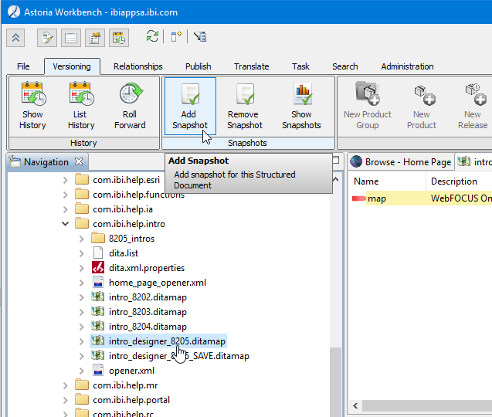
File Level:
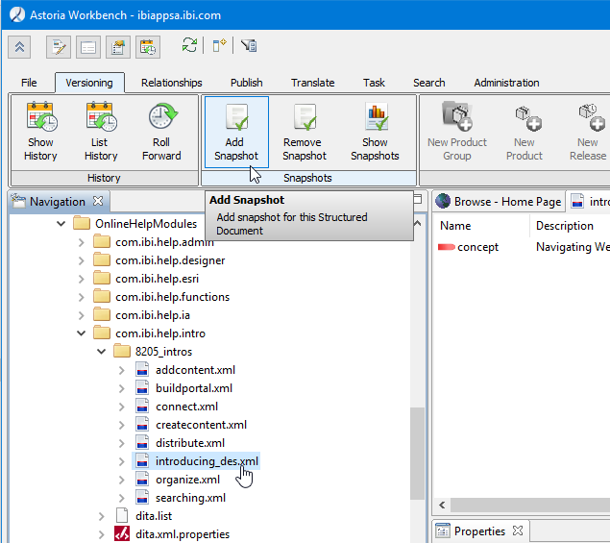
- Click the Versioning menu > Add Snapshot.
- Click the Snapshot Label drop-down menu and select the release number.
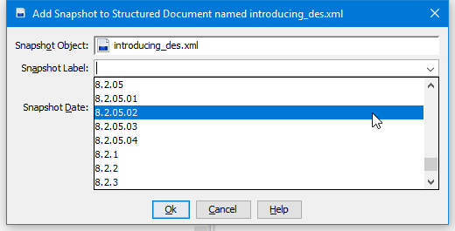
- Click OK.
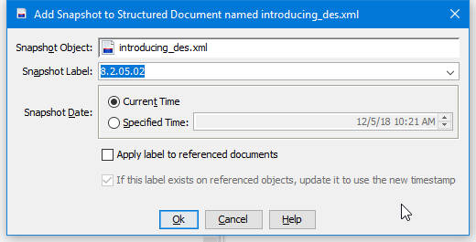

When to Use Snapshot Labels
Snapshot labels can be applied:
- Before the next release.
Snapshot label is added before updates for the next release are made. Even after GA release, changes to the manual may still occur so we wait until the next release updates are received.
Add the snapshot label to the ditamap and all files listed in the ditamap will inherit the snapshot label.
- For updating changes.
When the ditamap has an existing snapshot label, another snapshot label can be added onto a file that has been edited. This will update the timestamp of the snapshot label to have the latest changes made to the specified release.
- When maintaining concurrent releases.
While working on the next release, additional edits may also occur for a previous release. You will need to assess whether to make the edits now or to collect the changes to be made later if additional changes for a previous release will be forthcoming.
- If major edits or a collection of edits for an earlier release are made, add the snapshot label at the file level. Caution: If there are content for the next release that do not apply to the previous release you are making the edits for, you will need to roll forward the previous release first before making the edits.
- If minor updates are made, like a new or edited p tag, add the snapshot label at the element level.
Do Not:
- Add content for the next release while editing content for an earlier release. This will cause the new release content to display with earlier release content when snapshot label is added at the file level.
Solution: Once edits for an earlier release is complete, check-in the saved file and add the snapshot label at the file level.
- Add snapshot labels to certain element tags, such as concept and task, where there are no text but only other tags within it. The tags within this type of element tags will not inherit the snapshot labels.
Solution: Add the snapshot label at the file level.
- Add snapshot labels at both the file and element level at the same time. This may cause missing content when publishing with snapshot labels.
Solution: If occur, see Resolving Missing Content When Publishing with Snapshot Labels.

How to Add a Snapshot Label at the Element Level
- In the Navigation pane, select the element tag to add the snapshot label.
To apply snapshot label on element tags:
- If the update is at the parent level, e.g., a p tag, apply the snapshot at the p tag.
- If the update is at the child level, e.g., a step tag, apply the snapshot label at its parent level, e.g., the steps tag (see image below for an illustration).
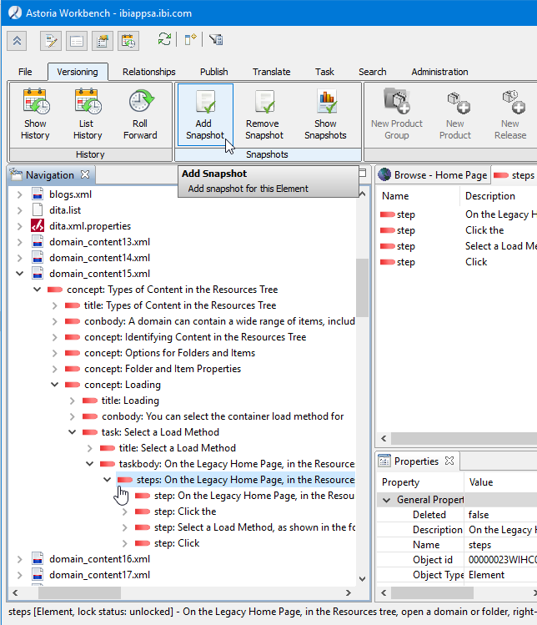
- Click the Versioning menu > Add Snapshot.
- Click the Snapshot Label dropdown menu and select the release number.
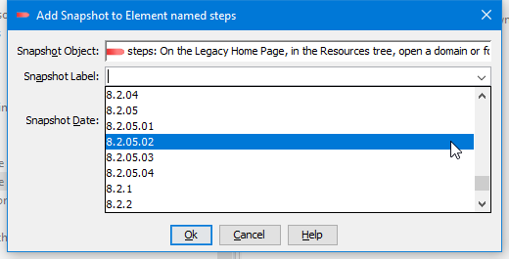
- Click OK.
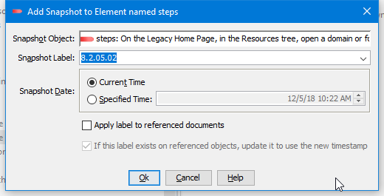

Publishing PDF
- In the Navigation pane, right-click the ditamap and select Publish > Compose With DITA-OT.
- Double-click ibi-pdf to add to the Present pane.
- To publish a previous release, go to Filtering and click the down arrow for the list of filtering options.
  - Select Snapshot Label.
  - Select a Release from the list of options from the Snapshot Label field.
- If the files have conditional text, then a ditaval file needs to be selected to publish the manual based on the specific product line. Click the Browse button.
  - Navigate to the location of the desired ditaval file, BI_Cabinet > ZZ_DITAVALS, select the file.
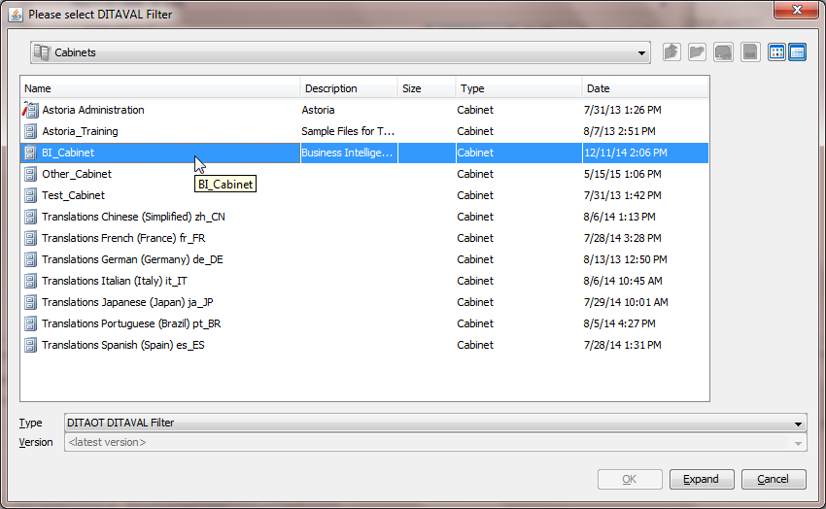
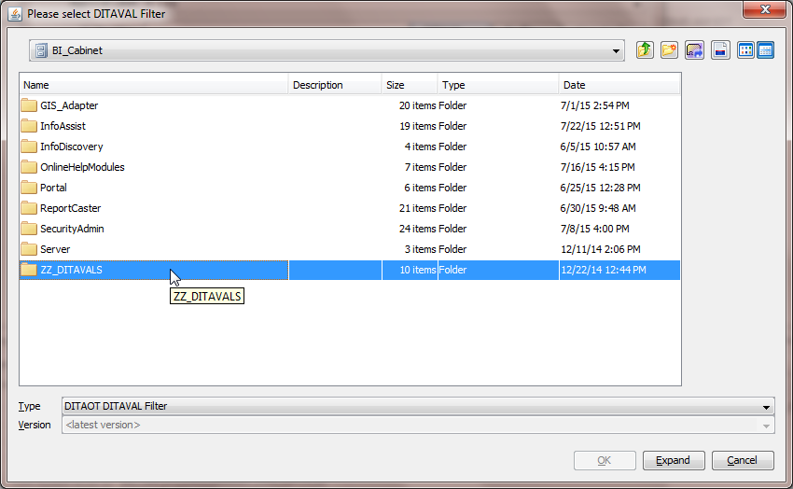
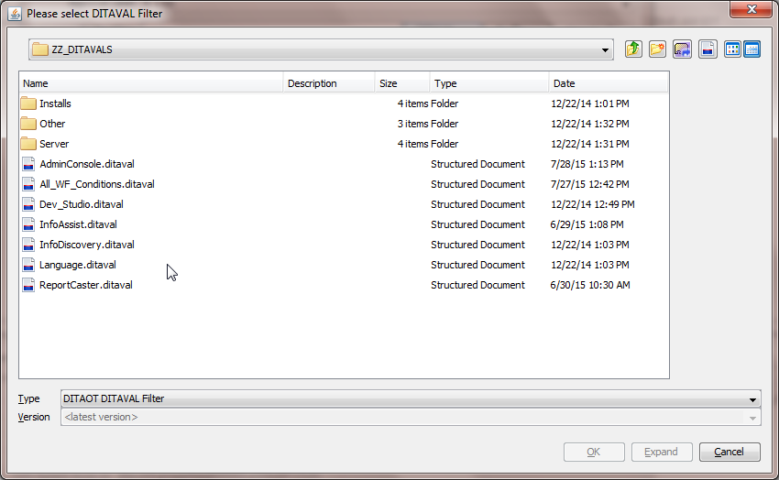
- Click OK to publish. When publishing is completed, an email will be sent with a zip attachment.
- Open the zip attachment to view the batch_err_xxxx.txt error log file.
xxxx is the unique id that Astoria assigns.
- Resolve the errors, if any and re-publish, and review the error log file. See Resolving Publishing Messages.
- Navigate to \\ibiappsa\Output\ibi-pdf\en-us\ open the PDF.
Note: This is the folder where all published PDFs will be located.
- Save the PDF to either your desktop or network.
Caution: Repeated publishing of the same PDF will be overwritten.

PDF Publishing Tips
- Images run off the page:
  - Check that the image is not too large; re-size the image to fit the page.
  - If more than one image in a row, separate each image with its own blank <p> tag.
- Codeblock runs off the page:
- If codeblock is too long, separate into individual <codeblock> tags.

Resolving Publishing Messages
- Missing content:
Missing content can happen if conditional filter or snapshot label is not applied appropriately. See:
- Resolving Missing Content When Publishing with Snapshot Labels
- By Attribute Filtering
- Missing images:
Look for missing images (marked with X box) which results in this type of message:
[DOTX031E][ERROR]: The file file:/D:/Astoria_Temp/batch8272@2018-01-26-10-10-48/temp-ibi-eclipse/01intro9.xml is not available to resolve link information. The location of this problem was at (File = D:\Astoria_Temp\batch8272@2018-01-26-10-10-48\database-export\portal8202.ditamap, Element = topicref:3;25:42)
Solution:
Go to the file (ex.: 01intro9.xml) that contains the missing images to link to the correct image path.
- Broken cross-references:
Look for unresolved cross-reference links in error log file which will identify the cross-reference link file and xml file that the unresolved cross-reference link is in.
Example of error message:
[DOTX031E][ERROR]: The file file:/D:/Astoria_Temp/temp366103//XML/en_US/77_06/ResGovernor/ACrg20.xml is not available to resolve link information. The location of this problem was at (File = D:\Astoria_Temp\temp510266\rulefiles16.xml, Element = xref:2;85:123)
Solution:
Go to the file (ex.: rulefiles16.xml) that contains the broken x-ref (ex.: ACrg20.xml) to resolve it.
Another type of broken cross-reference error message:
[DOTX026W][WARN]: Unable to retrieve linktext from target: '06WF_GIS48.xml'. Using navigation title as fallback. The location of this problem was at (File = D:\Astoria_Temp\temp279679-database-export\wf82gis.ditamap, Element = topicref:34;25:3466)
Solution:
Go to the file (ex.: 06WF_GIS48.xml) containing the broken cross-references to resolve them.
- Bad links in ditamap:
When receive this error message:
D:\Program Files\Astoria Software\ACS\DITA-OT_Test\plugins\org.dita.base\build_preprocess.xml:24: Failed to run pipeline: [DOTJ012F][FATAL] Failed to parse the input file 'D:\Astoria_Temp\temp237407-database-export\wf82gis.ditamap'. The XML parser reported the following error: : null
Or
This message appears:
[DOTJ054E][ERROR] Unable to parse invalid href attribute value "e:\output\publish\publish.eclipse_ast.online-help\ls03519\xml\en_us\82_01\fixedin\source\www.informationbuilders.com", using '/e:/output/publish/publish.eclipse_ast.online-help/ls03519/xml/en_us/82_01/fixedin/source/www.informationbuilders.com'.
Solution: Edit the ditamap and look for links that do not start with http://ibiappsa.ibi.com/astoria/_id_ ...
OR
There could be a file that has a product condition that does not belong in the ditamap and the error message states:
[DOTX026W][WARN]: Unable to retrieve linktext from target: 'DisplayFormats114.xml'. Using navigation title as fallback. The location of this problem was at (File = D:\Astoria_Temp\batch6260@2018-03-26-15-12-15\database-export\8203_crlang_jb.ditamap, Element = topicref:104;465:42)
Solution1: Check the file listed in the error message and if that file is conditionalized for a different product line, for example, FOCUS, then edit the ditamap to remove the file.
Or
Solution2: Check the image’s href begins with http://ibiappsa.ibi.com/astoria/_id_ ... If not, find the image in Astoria or import the image into Astoria.
- Ignore these messages references to PDF link, appendix and ref:
[DOTX003I][INFO]: The anchorref attribute should either reference another dita map or an Eclipse XML TOC file. The value 'Launch PDF:as_user_guide.pdf' does not appear to reference either. The location of this problem was at (File = D:\Astoria_Temp\temp117766-database-export\apps_help.ditamap, Element = navref:1;496:73)
[DOTX019W][WARN]: The type attribute on a topicref was set to 'appendix', but the topicref references a 'topic' topic. This may cause your links to sort incorrectly in the output. Note that the type attribute cascades in maps, so the value 'appendix' may come from an ancestor topicref. The location of this problem was at (File = D:\Astoria_Temp\temp181026-database-export\zos_install.ditamap

Resolving Missing Content When Publishing with Snapshot Labels
Snapshot labels may be applied at the map, file, and element level.
Snapshot label is set when the manual has been finalized and approved by the product manager. This is set at the map level which all files listed in the map will inherit the snapshot label. This captures all the updates for the specified release with a timestamp which can then be published at any time.
If additional updates were made after the snapshot label had been applied, then the snapshot label should be applied at the file level.
If there are missing content that were made for an earlier release, it may be that snapshot labels were applied at both the file and element levels. This interferes in correctly publishing the content. The remedy is to keep the snapshot label at the file level (root concept element) and removing those on the element levels.
The quickest way to check all of the elements in a document for snapshot labels is to search for them:
- Select the document that has the missing edits in the published manual.
- Click the Search tab and complete the following search fields:
  - Find: Elements
  - By: Name
  - Operator: Is Not
  - Value: xyzxyz
  - Limit: 10000 (10,000 without the comma)
This finds all of the elements in the document (since none are named "xyzxyz"). In the Details view that lists the results, turn on the Snapshot column. You should see the Snapshot Label on the root concept element and sort by Snapshot column. If snapshot labels appear on other elements except for the root concept element, remove them:
- Select each element that has the snapshot label.
- Go to Versioning > Remove Snapshot Label.
- Select all the snapshot labels listed and click the Remove button.
- Then click the Close button to exit the dialog box. Note: It will take a few minutes for the dialog box to close.
- Repeat these steps until all snapshot labels, except the one at the root concept element, are removed.
- Then re-publish the content with the Snapshot Label filter option.

Search Function
Astoria’s Search function provides multiple methods for finding objects or content of interest in the repository. The drop down lists for Find, By and Operator fields cover many search scenarios for refining search results. Taken from Astoria help, the tables below descriptions search objects.

Find
Select the type of object to search for. Generally you select this value first, because it determines the other criteria options.
Object Type | Description
All Documents | Returns all document types.
DTDs | Returns DTDs.
Editions | Returns editions.
Elements | Returns elements.
External Files | Returns external file placeholders.
Files | Returns unstructured files, such as graphics, text, spreadsheet, PF.
Folders | Returns folders.
Product Groups | Returns product groups (from Release Management Products area)
Products | Returns products (from Release Management Products area)
References | Returns references, such as shortcuts.
Releases | Returns releases (from Release Management Products area)
Searches | Returns saved searches.
Structured Documents | Returns XML documents, including DITA topics and maps.

By
Select the criteria by which to find results. The options available in the By field are determined by the selection made in the Find field.
Criteria | Description | Objects Available
Content | Find objects with this content. | - All Documents  - Editions  - Elements  - Files  - Structured Documents
Attribute | Find elements with this attribute. | Elements
Custom Attribute | Find objects with this custom attribute. | All
Description | Find objects with the specified value in the Description field. | - All Documents  - DTDs  - Editions  - External Files  - Files  - Folders  - Product Groups  - Products  - References  - Releases  - Searches  - Structured Documents
Name | Find objects with this name. | All

Operator or @Value
Select the search operator criteria for how to match objects. The @Value field appears only when the By criteria specifies an Attribute or Custom Attribute.
Operator | Description
Contains | The object must contain the Value string in the By criteria.
Does Not Contain | The object must not contain the Value string in the By criteria.
Is | The object must match exactly the Value string in the By criteria.
Is Not | The object must not match exactly the Value string in the By criteria.

@Name is
Identify the object name to find. This field appears only when the By criteria specifies an Attribute or Custom Attribute.
By Criteria | Description
Attribute | Type in the attribute name.
Custom Attribute | Select the Custom Attribute from the list.  Note: A custom attribute is included in the list only if the Searchable check box is selected in its Properties sheet.

Value
Type in the value to use in the search.

Limit
Specify the maximum number of search results to return. Specify a value of 0 to use the system-defined limit.
Common examples of search function
- To search for XML files, complete the fields:
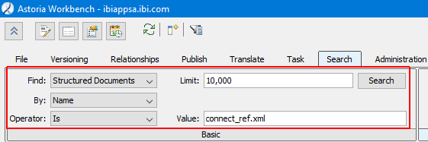
- To search for attribute:
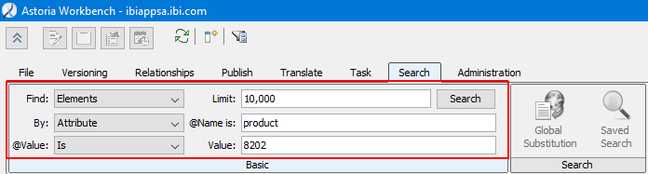

- To search for content:
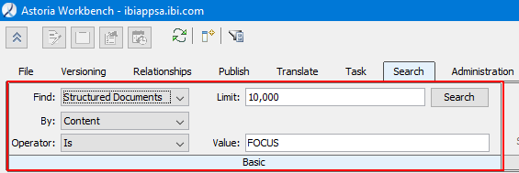

Global Substitution
The Global Substitution tool can modify multiple documents. The tool performs a Global Replace, which is a part of a Global Find/Replace process.
Using an editor Find/Replace tool is insufficient because the elements or text objects to be changed reside in different documents. The Global Substitution tool allows a user to make global substitutions. Besides text, attribute values may also be globally replaced and also include altering metadata such as Snapshot Labels, custom attributes or annotations.
Permission to use the Global Substitution tool is provided only to users who are members of the Global Substitution Group. Users of the tool must also have access to and permission to revise the document. An error is reported when the user is not authorized to revise a document. All writers and tech editors are members of the Global Substitution Group.
Document elements and text objects reside in locking units. The locking unit is automatically checked out to the requesting user who uses a substitution rule to change an element or any of its text children. An error is reported if another user currently holds a lock on a needed locking unit.
The substitution process involves identifying candidate items to change, then applying changes specified in an ordered list of substitution rules against the collection of candidates. When the process completes applying the last rule to the last document element of the collection, the substitution processor will optionally check in the relevant locking units using the version note specified in the job.
Note: No validation is performed. We recommend that you validate the change before checking in locking units of the affected elements. If undesired changes are made, the checkouts can be revoked and the substitutions are discarded.
Important Note: For larger manuals, several iterations of these steps are needed to ensure all files have been searched for global substitution.

How to Use Global Substitution
Searching for text to replace:
- Navigate to the cabinet and folder to begin the search. Click the Search tab.
- Complete the following fields:
  - Find: Elements
  - By: Content
  - Operator: Contains
  - Limit: A numeric value displaying the maximum number of results
  - Value: A word or phrase to search for
The following image is a sample of completed fields.
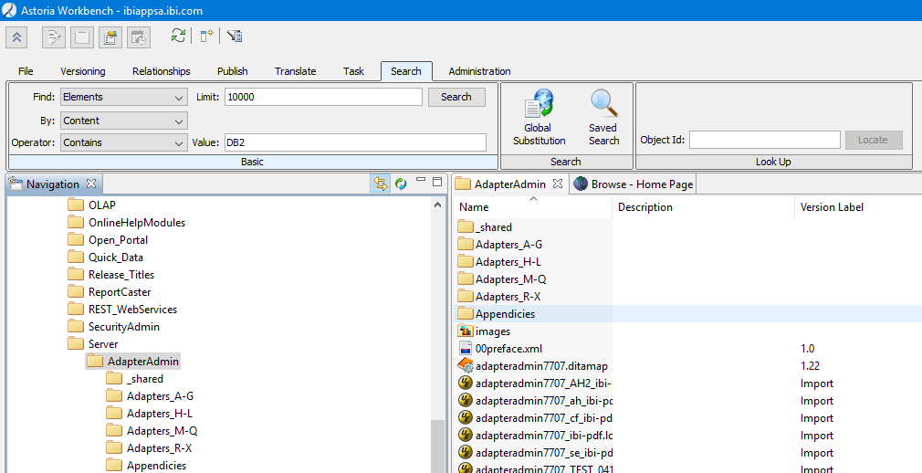
- Click the Search button.

- Select all of the results and click the Global Substitution icon.
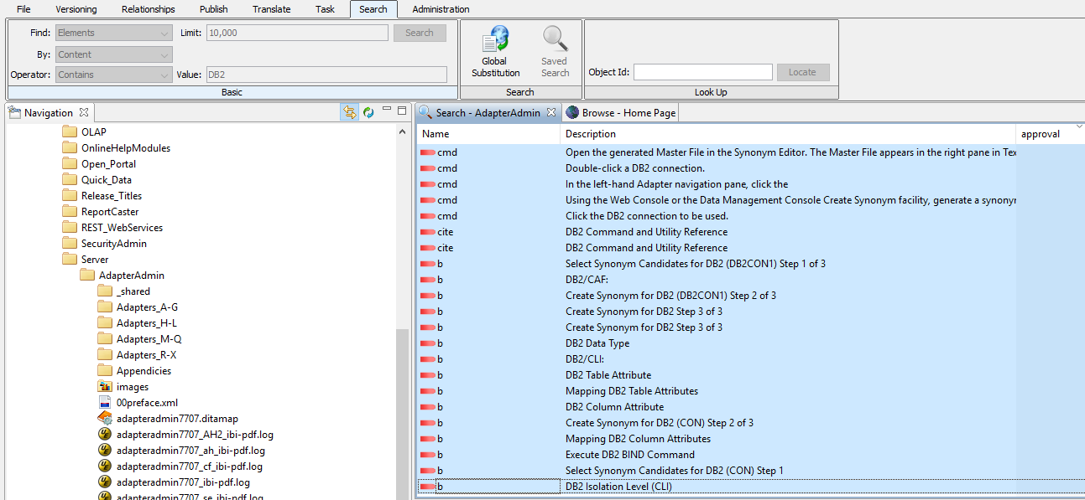
- Complete the following fields:
  - Type: Change Text
  - Find: Word or phrase that was searched for
  - Replace With: A replacement text
  - Case-sensitive: Check to enable (if necessary)
  - Check-In: Click to check-in files once changes are made
Important: Ensure this box is checked. Otherwise, you will need to manually check-in each file that has changed.
  - Version Note: Description for the Find/Replace
The following image is a sample of completed fields.
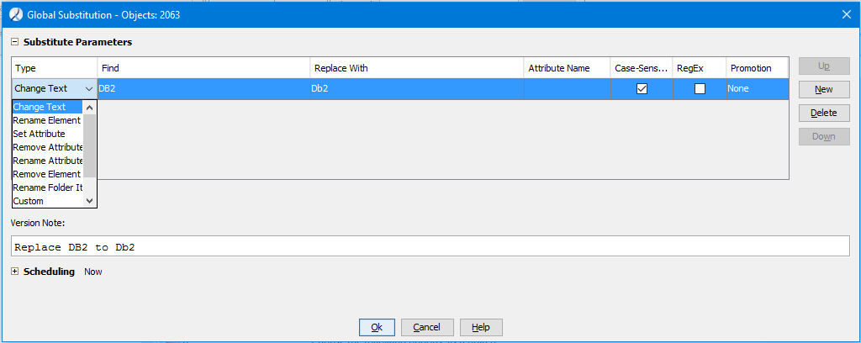
Note: The Type drop-down list has hidden the Check-in checkbox.

- Click Ok.
You will receive an email when the global substitution has been completed.
Important Note: For larger manuals, several iterations of these steps may be needed to ensure all files have been searched for global substitution.
Searching for an attribute value:
- Navigate to the cabinet and folder to begin the search. Click the Search tab.
- Complete the following fields as shown in the following image.
  - Find: Elements
  - By: Attribute
  - Operator: Contains
  - Limit: A numeric value displaying the maximum number of results
  - Value: Attribute value for the search
The following image is a sample of completed fields.
- Click the Search button.

- Select all of the results and click the Global Substitution icon.
- Complete the following fields:
  - Type: Change Text
  - Find: An attribute value
  - Replace With: A replacement value
  - Case-sensitive: Check to enable (if necessary)
  - Check-In: Click to check-in files once changes are made
Important: Ensure this box is checked. Otherwise, you will need to manually check-in each file that has changed.
  - Version Note: Description for the Find/Replace
The following image is a sample of completed fields.
Note: The Type drop-down list has hidden the Check-in checkbox.

- Click Ok.
You will receive an email when the global substitution has been completed.
Important Note: For larger manuals, several iterations of these steps may be needed to ensure all files have been searched for global substitution.

Offline Editing
Astoria files can be edited offline without logging into Astoria. Checked out files are downloaded locally to the desktop found in your Users folder:
C:\Users\user_id\.astoria\sandbox\ibiappsa.ibi.com\astoria_filename.xml
The checked out files remain locally on the desktop until they are checked back into Astoria. Once the file is checked back into Astoria, it is deleted from your desktop.
While attempting to open a checked out file offline in XMetaL, Astoria will request that you log in. Cancelling the log in request will still display the file for editing.

How to Edit an Astoria File Offline:
- Log into Astoria.
- Navigate to the cabinet/folder to select the file for editing offline.
- When the file is open in XMetaL, choose one of these actions to close the file:
  - Right-click the file tab and select Close.
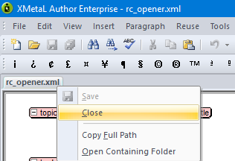
or
  - Close XMetaL.
The checked out file is downloaded to your local desktop and located in C:\Users\user_id\.astoria\sandbox\ibiappsa.ibi.com\astoria_filename.xml.
- Close Astoria.
- Navigate to the location of locally saved file and open in XMetaL.

- A series of dialog boxes appear. Do the following:
  - Click Cancel at the Enter Credentials dialog box.
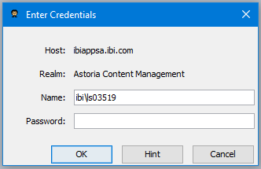
  - Click OK when login error message displays
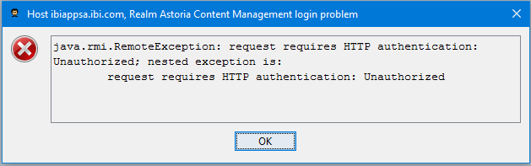
  - Click OK again when another error message displays:
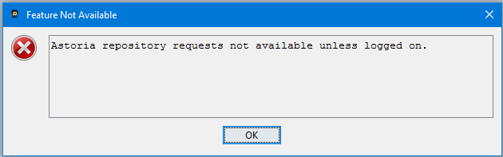
Then the file is open; you can begin editing the file.

How to Check-in Offline Editing File
Since the file is still checked out, you need to check-in the file to the Astoria repository to save the edits you made.
- Log into Astoria.
- Navigate to the cabinet/folder where the checked out file is located.
- Select the checked out file to edit.
- When file is open in XMetaL, scan to verify that the offline edits appear.
- Click the Repository menu and select Check in Document.
- Enter a description of the edits made in the Version Note field.
- Click OK.

Resolving Windows Security Message in XMetaL
If opening an Astoria .xml file to edit in XMetaL and a Windows Security login displays, this indicates that an odd character image was introduced into the file. This occurs when copying and pasting text from another application into XMetaL. Any unusual character may be considered an entity which must be declared. For example, LI__1 entity.
To resolve this is to edit the file in plain text to remove the declaration and its entity.

Resolving XMetaL Log-in Message
We recently encountered a different error message that caused XMetaL to display a login screen. This error was caused by images. It was discovered when the publishing log indicated that there were deleted images in the Astoria Wastebasket that the file needed in order to publish the manual successfully. When attempting to edit the file that had the missing images, the login screen displayed. We had to cancel the login screen three times before XMetaL allowed the files to open.
We do not entirely understand why it caused this error. It occurred when images were deleted from Astoria and later replaced with updated images that had the same names. It also could be the method the images were inserted into the file, but that has not been confirmed.
To resolve this error, all images had to be re-inserted since we did not know which one caused the error.

